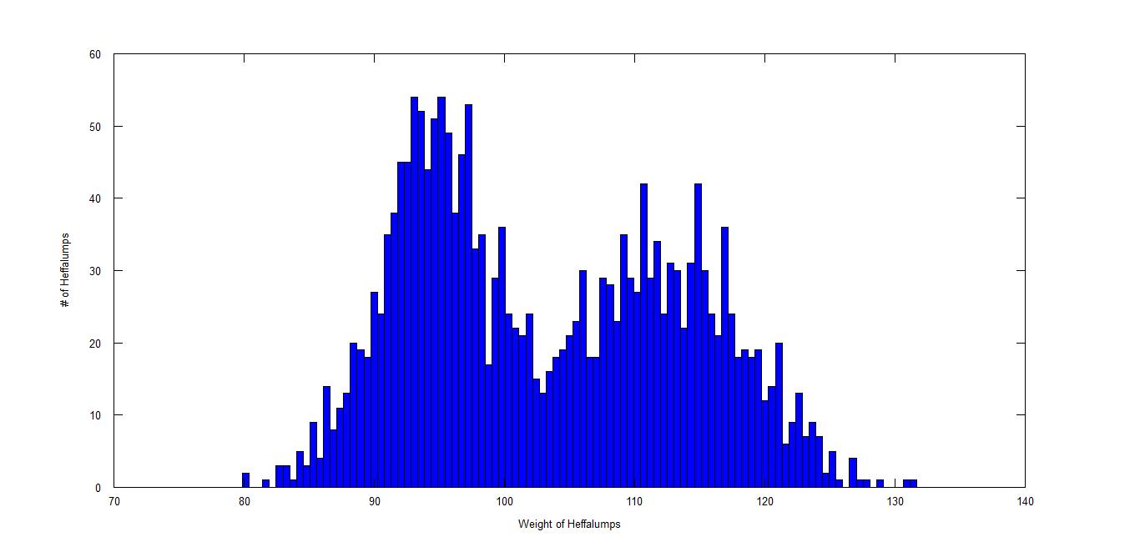

The weight distribution is not Normal as most wild populations should be. An explanation for the 2 peaks in the distribution could be that the male and female Heffalump weights differ enough to change the distribution of the whole population.

In order to test this hypothesis, we can take female and male populations and measure each gender separately. By doing so, we can see if the distribution, for each gender, follow a Normal distribution.